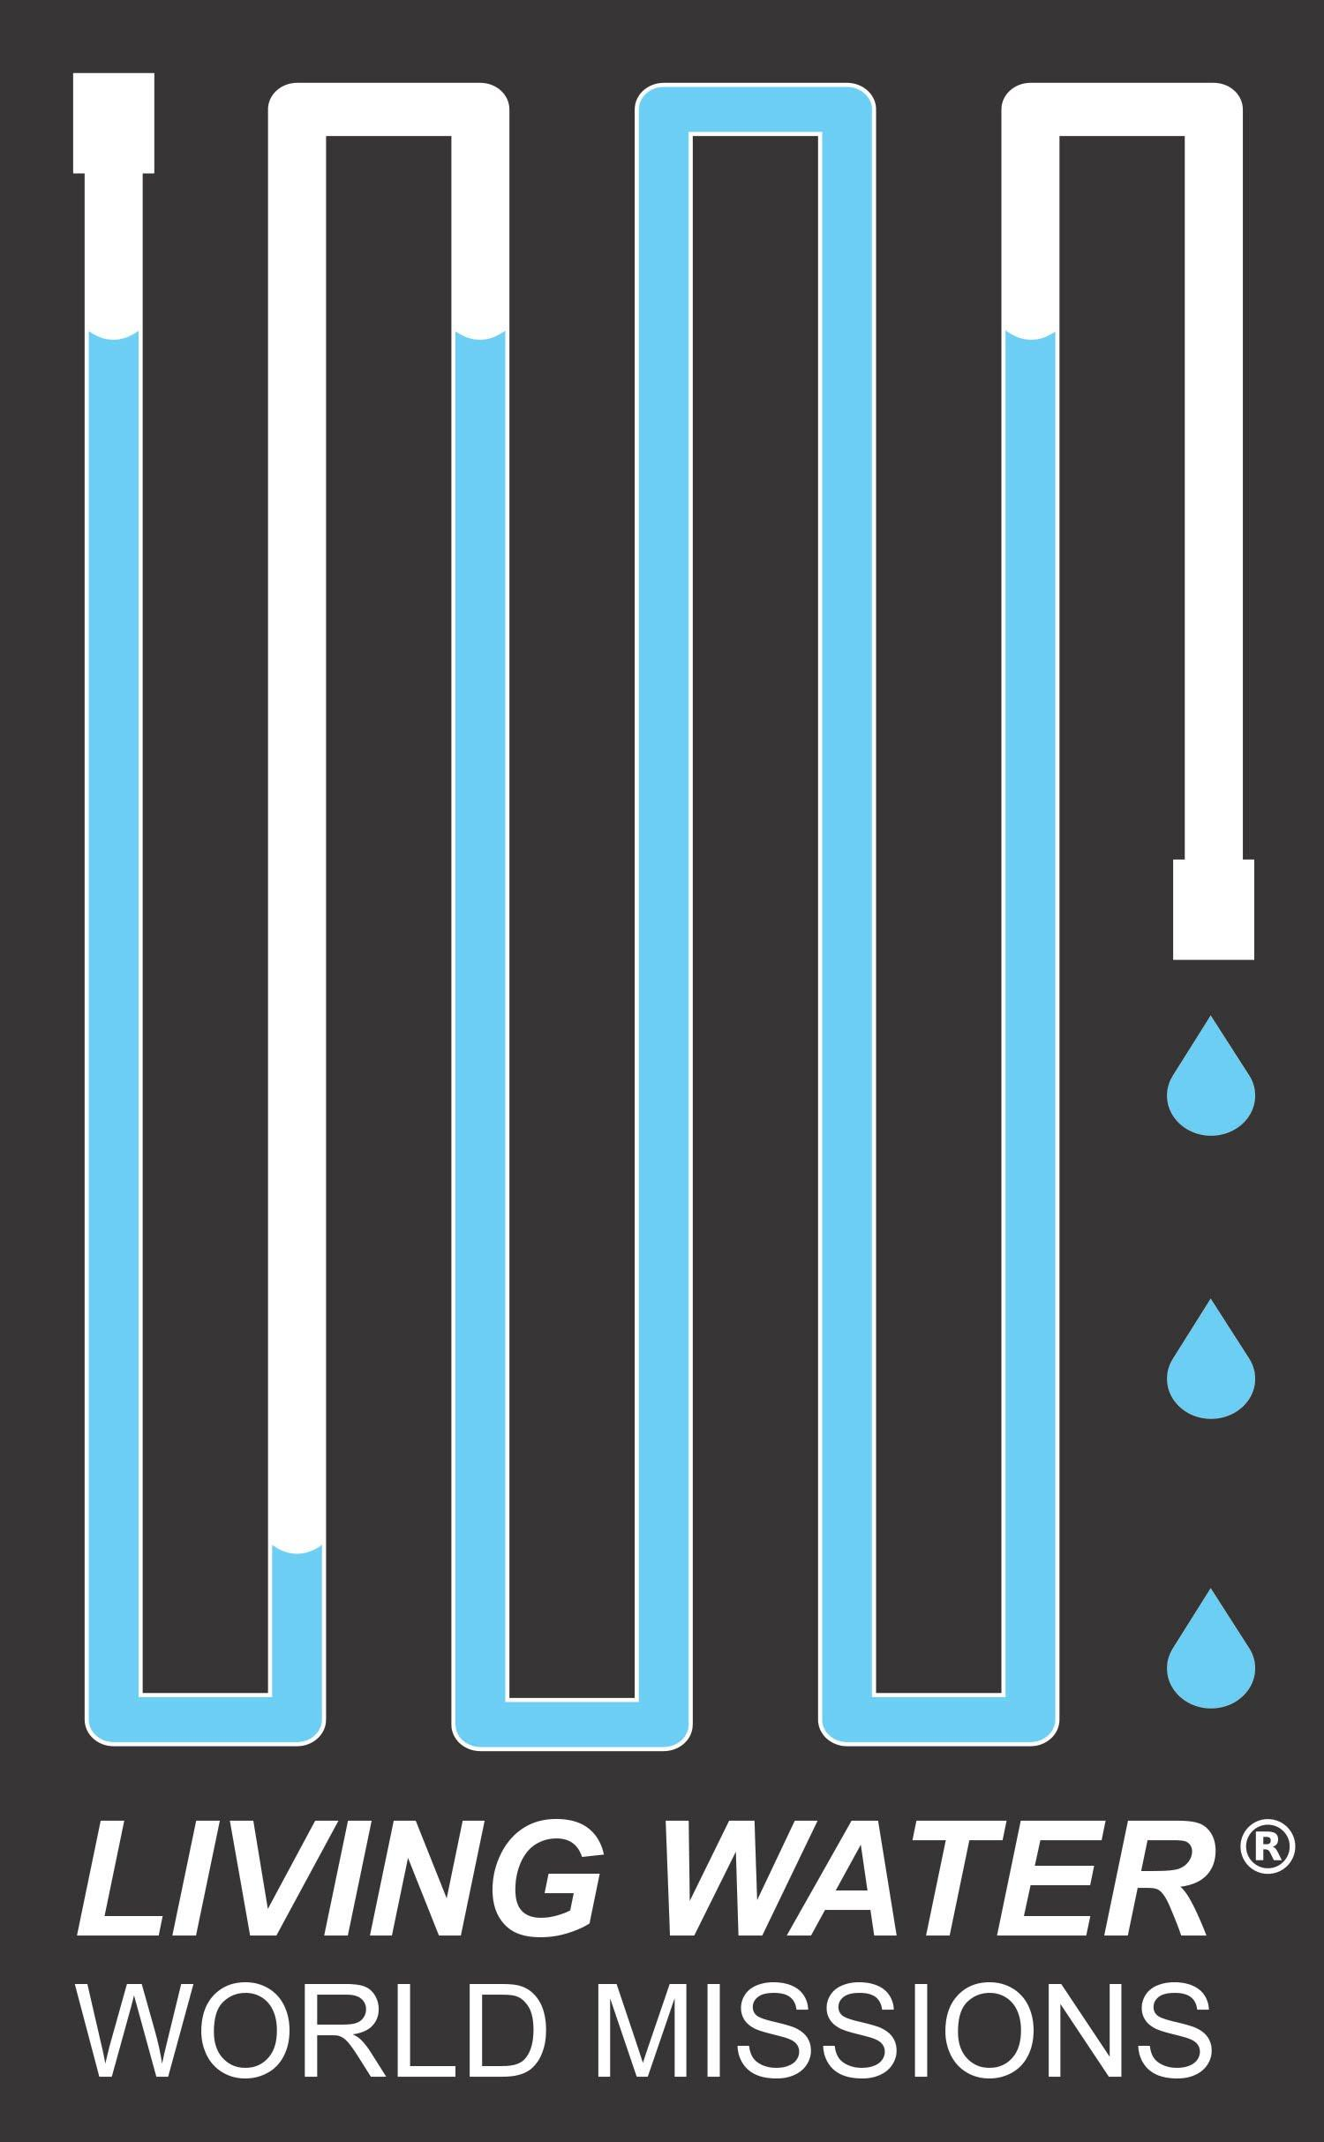
Living Water World Missions
SHORT TERM MISSION TRIPS

Team Member Requirements, Policies, and Trip Overview

Living Water World Missions (LWWM) is a 501 C3 non-profit ministry that exists to share the Gospel of Jesus Christ in the context of installing sustainable water purification systems wherever they are needed. We team with local entities (such as schools, churches, or orphanages) to provide clean water to people who need it by constructing and installing a system that uses filters and ozone to purify the water. In addition, we train adults and children in basic community health and hygiene practices using Bible stories, science demonstrations, and activities. We have focused our attention on Guatemala where we have local staff and a network of support.

We have three simple goals:
- Share the Gospel in word and action; build long lasting relationships based on shared faith and trust.
- Train partners to construct and maintain a water purification system.
- Train partners in the areas of community health and personal hygiene.

Team Member Requirements:
To be accepted on a team, you must be physically, mentally, and emotionally fit and meet the following minimum requirements.

Age requirements: Any age is welcome on a LWWM team.
1. Team members 16 years of age and younger must have a parent or other adult who will be responsible for them while on the mission trip
2. Parental or legal guardian permission is required for team members who are under 18 years of age or in high school.

Physical and Health Requirements:
1. Ability to walk independently over uneven terrain for at least a quarter mile.
2. Ability to pull/carry baggage totaling up to 50 pounds independently.
3. Ability to work in an adverse climate for up to 8 hours at a time at elevation above 5,000 feet.
4. Responsible for consulting personal physician regarding health risks, CDC recommended vaccinations, and preventative treatment or measures for mosquito-transmitted diseases, as well as any vaccinations required by the destination country.

Team Cooperation Requirements:
1. Commitment to submit to the trip leader.
2. Ability to get along well with others; willingness to room with the person assigned to you.
3. Required participation in nightly devotions.
4. Ability to assist the trip leaders in the technical aspects of constructing the system and teaching basic health and hygiene principles.
5. Due to the political instability and anti-American sentiment in various countries, LWWM asks that team members refrain from expressing political opinions while overseas.

Financial Requirements:
- Responsible for 100% of trip costs including airfare and any medical costs incurred during the trip.
- Donations made to Living Water World Missions, including for participation in a mission trip, are considered charitable contributions for federal income tax purposes to the extent permitted by law. Deposits are refundable before airfare is purchased on your behalf or prior to 30 days before the trip if you purchased your own airfare.

Trip expenses:
Please note the cost of each trip will be $700 per person for all in-country expenses including lodging, food, and ground transportation. Extra days/excursions/souvenirs are the sole responsibility of the participant. Airfare varies and is an additional cost. Participants who cannot fly out of LAX will be responsible for arranging their own air transportation to Guatemala. Normally, the total cost of the trip ranges from $1,200 to $1,450 per person. Each participant is required to obtain travel medical insurance that will cover a minimum of $15,000 of coverage for medical expenses abroad.
Team Member Expectations:
Trip overview:
Our Guatemala trips usually last 8 days, from Saturday to Saturday, with two days of travel to our final destination on both ends of the week. The team will fly into Guatemala City in most cases. Typically, installation work, education instruction, and community outreach will take place between Monday and Thursday. Please see typical schedule found on our website.
Trips to Central America/Caribbean are not for the faint hearted. We often work in high heat, humidity and elevation, and food may be different from that which we normally eat. Mosquitos are ever present at lower elevations. See requirements above. Be advised that national regulations in Guatemala may impact our travel in and out of that country. This may include, but is not limited to, required vaccinations, health forms, or notarized documentation.
Team members must adhere to the behavioral guidelines that are set by the team leadership, with a mind toward the culture to which the team is going. This will require a servant attitude toward all nationals and team members, as well as the willingness to learn from the host culture.

Our role in mission projects:
If we do our job well, we will do little of the hands-on work because our Guatemalan employees will do most of the instructing and our Guatemalan friends on the installation and teaching sides will do the building of the system and the teaching of the children. To put it clearly, the Americans DO NOT build the system and we DO NOT teach the children. That is the job of our partners with our support and supervision. This is important because we know that for a water system to be sustained long-term and for on-going community education to take place, our partners must know and own the information.
What this means is a changed role from what you may have previously experienced on other mission trips. For us, relationships are critical despite the language barrier. We urge you to consider how the Lord may use you to build bonds of friendship. We urge you to consider how you might best spend your week in a support role. We urge you to consider how your skills, talents, and passions can be put to effective use.

If you believe that God is calling you to this ministry, we invite you to complete the application.

Please follow the instructions on page three and fill out the application accurately and completely. Incomplete applications may exclude you from participation on a trip. The application is designed for you to fill in the form on a computer and then print to submit via USPS along with trip deposit. To make arrangements to submit application and payment electronically, contact Kami Lanting at klanting@livingwaterworldmissions.org.

God bless you as you consider helping us provide clean water to God’s children.

Living Water World Missions
SHORT TERM MISSION TRIP APPLICATION

Please complete the following application on your computer. It is a fillable form. Handwritten applications will NOT be accepted. A fee of $250 is required for each application as a deposit towards trip expenses.

Dates of mission trip for which you are applying:

Full legal name (EXACTLY as it appears on your passport):

Name you prefer to be called: Gender: Citizenship: Birthdate:

Passport Number: Expiration Date: Country of Issue:
Include a copy of your passport with this application, or send separately if you are applying for a passport. Passport must be valid for six months beyond departure date.

Home Address (Street, City, Zip):
Phone: (Home) (Cell)
Email:

Emergency Contact: Phone: Relationship:

Reference: Name: Phone: Relationship:

Home Church (name and location):

T-shirt size:
Skills and Abilities:
Is this your first international mission trip?
Do you speak Spanish? If yes check one: fluently? Conversationally? A Little?
List your skills and experience that might be helpful, such as plumbing/construction, engineering, teaching experience, previous mission trips, etc…. (1000 character limit)

By your initials, please confirm you are willing and able to do the following:
- Walk independently over uneven terrain for at least a quarter mile. initials
- Pull/carry baggage totaling up to 50 pounds independently. initials
- Work in an adverse climate for up to 8 hours at a time at elevation above 5,000 feet. initials
- Consult personal physician regarding health risks, recommended vaccinations, and preventative treatment or measures for mosquito-transmitted diseases. initials
- Actively help with construction of the water system and/or teaching health and hygiene. initials
- Submit to the authority of team leaders, remain joyful under difficult circumstances and maintain a sense of humor. I commit to nightly devotions. initials

PHOTO/VIDEO Release
By signing this application form, I hereby grant permission to Living Water World Missions to the rights, without payment or any other consideration, to my image, likeness, or sound of my voice as recorded on audio or video file. Photographic, audio, and video recordings may be used by Living Water World Missions for the following purposes: informational presentation, promotional materials, newsletters, websites, and social media.

FINANCIAL Notice of understanding
It is my responsibility to secure the necessary finances for this mission trip. Donations made to Living Water World Missions are considered charitable contributions for federal tax income purposes to the extent permitted by law. Deposits and payments are refundable before airfare is purchased on your behalf or prior to 30 days before the trip if you purchased your own airfare.
Minor Trip Participants
If applicant is a minor who will NOT be accompanied on the trip by parent or guardian please find the minor release forms (required by international laws with notarization) on our website and include with application and deposit. If you are under 16 you must have a parent or other adult who is responsible for you while on the trip.
Authorization
The information on this application form and on any attached forms is correct to the best of my knowledge. Additionally, I have read and agree to the Photo/Video Release, Notice of Understanding, Financial Notice of Understanding, and all Team Member Requirements.
I authorize any references to release all such information, as it will assist in the evaluation of my participation on a Living Water World Missions mission trip. I release all references from liability for any damage that may result from furnishing such information to LWWM. I waive any right that I may have to inspect references or the background check. I hereby give LWWM permission to contact my references.
I have read and agree to abide by the policies set forth on the form, including stated goals and mission of Living Water World Missions.

Date _______ Signature of Participant________________________________________

Printed Name of Participant __________________________________________

If the applicant is a minor (under 18 years old) or is still in high school:
Date _______ Signature of Parent/Legal Guardian___________________________________

Printed Name of Parent/Legal Guardian __________________________________________

Please print, sign, and return all forms (application and liability release), along with the required deposit of $250 payable to Living Water World Missions, to:

Living Water World Missions
Attn: Kami Lanting
PO Box 7509
Visalia, CA 93290

Living Water World Missions
Short Term Trip Medical and Liability Release
PERSONAL DATA
Name (exactly as shown on passport): Birthdate:
Complete Address:_
Phone: (Home) (Cell) (Work)
E-mail:
EMERGENCY CONTACT (For those younger than 18 years of age or still in high school, provide parent/guardian info.)
Name(s): Relationship:
Phone: Home Cell Work
Complete Address:
MEDICAL INFORMATION LWWM requires all team members to obtain international medical insurance
State of your present health (check one): Excellent Good Average Poor
If you have any medical problems, regularly use any medication, have a special diet or allergies (including allergies to medications), or have had a major illness or surgery within the last 12 months, please provide that information. (1000 character limit)

Date of last tetanus shot (must be within the last 10 years): Blood type if known:
Physician’s Name: Address: Phone:
Permission and Liability Release
I, , certify that I am in good health and have received or will receive all vaccinations recommended by my county or state health department for travel in the countries or areas to be visited on this trip. I understand that dietary accommodations will not be possible on this trip.
I am aware that the mission trip to Guatemala poses risks including but not limited to: sickness, crime, political instability, governmental opposition, personal injury, death, as well as similar and dissimilar risks. I am voluntarily participating in the mission trip with the knowledge of the risks involved. I hereby agree to accept any and all risks of injury or death that may result from my participation in the mission trip. I hereby irrevocably and unconditionally release, waive, discharge, and covenant not to sue or attach the property of Living Water World Missions, or any of their affiliates, subsidiaries, divisions, members, directors, officers, employees and agents (collectively referred to as the “Releasees”), for and from all claims of any nature now or hereafter existing whether known or unknown, including but not limited to all liability, on account of death, injury, or damage resulting from the negligence or other acts, however caused, of the Releasees as a result of my participation in the mission trip. I understand that I am giving up my legal rights and the rights of my representatives to recover for injury, death, or property damage.
Further, authorization and permission are hereby given to said organization to furnish any necessary transportation, food, and lodging for this participant. The undersigned further hereby agrees to hold harmless and indemnify said Releasees for any liability sustained by said organization as the result of the negligent, willful, or intentional acts of said participant, including expenses incurred attendant thereto. If during the course of this mission trip I or my child-participant should become ill or sustain an injury requiring medical attention, I hereby authorize representatives of Living Water World Missions to obtain emergency medical services on my behalf, including medical evacuation. I will assume financial responsibility for the bills incurred. I have carefully read this agreement and fully understand its contents. I am aware that this is a release of liability and a contract between myself on the one hand, and LWWM and/or their affiliates on the other hand. No oral representations, statements, or inducements apart from this agreement have been made to me. I sign this agreement of my own free will.
I further acknowledge that Living Water World Missions has recommended that I carry or obtain primary medical insurance to cover possible medical needs including evacuation occurring during this trip and that Living Water World Missions has recommended that I obtain travel insurance covering personal injury, trip delay, change or cancellation, loss of or damage to baggage, and other standard risk coverage for this trip.
I hereby assume all risk of personal injury, sickness, or death, and damage to or loss of my personal property, and any delay, change or cancellation of travel arrangements, and any and all other damage or expenses I may suffer as a result of participation in this ministry/mission trip or in activities related to it. I agree to be fully responsible for my actions.

Date _______ Signature of Participant________________________________________

Printed Name of Participant __________________________________________

If the applicant is a minor (under 18 years old) or is still in high school:

Date _______ Signature of Parent/Legal Guardian___________________________________
Printed Name of Parent/Legal Guardian __________________________________________

