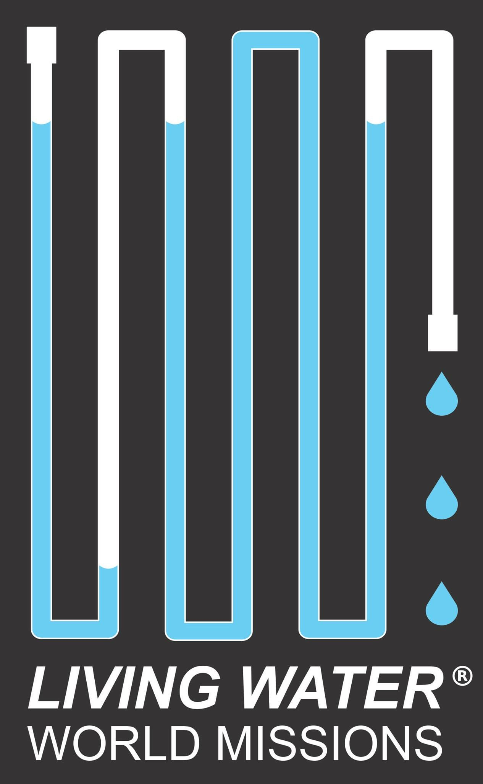

Guatemala Installation Trip Information
2019

Non-refundable payment of $250.00 is REQUIRED TO RESERVE your spot along with a COMPLETED application form.

WHAT IS INCLUDED
- Flights from/to LAX (unless you are booking your own)
- 3-star hotels (or best available in some areas), DOUBLE occupancy
- Breakfast, lunch, & dinner each day
- Airport transfers, Comfortable bus
- English speaking, knowledgeable guides
- Tips, service charges, site entry fees, and VISAS/border fees where needed

WHAT ISN'T INCLUDED
Snacks, Personal expenses, 3% fee if final payment is made with credit card, Single occupancy room, Global Entry/TSA Pre-Check (optional)

WHO CAN TRAVEL
Anyone who can manage their travel and time independently is welcome.
Travelers should be healthy enough to walk comfortably over uneven terrain, climb and descend stairs, sit for bus rides, manage their own luggage, and enjoy long days with walking up to 3 miles. Those who become ill or too tired to participate can stay at the hotel (if the bus is returning at day's end) or on the bus. We welcome anyone from any church or location to join us.

SAFETY
We had NO safety issues on any pervious trips. Travel advisories are monitored and, if our in-country itinerary has to be adjusted, it will be. It is clear that U.S. tourists are valued and accommodated.

VISAS AND PASSPORTS
All travelers will need a passport that expires at least 6 months AFTER wearrive home.

GLOBAL ENTRY/TSA PRE-CHECK
You can use them if you have them. They will only help you get through U.S. Customs faster, not internationally.

Mobil Passport App = Highly recommended! (Free)

ROOMMATES
If you do not have a roommate to travel with, we assign you one among other solo travelers.
LUGGAGE
ONE 22" max wheeled bag and a backpack/tote. See the separate Packing Guidelines. You do not need much gear for this trip. You must be able to carry your own luggage.
You may also be assigned a team bag that may weigh up to 50lbs (with rollers) that you will be responsible for at airports.

HOTELS
The best hotels in the area will be provided and most are 3-star (standards for
these countries are a little less than U.S. but all are clean and comfortable).
Wi-Fi is available in most hotels. Laundry/ironing facilities may be arranged through hotel services for a fee.

FOOD/DRINKS
In Guatemala health standards are not what we are used to. Water and anything washed in water should not be consumed without risk of illness. Your guide will explain what we can and cannot eat. There is plenty of edible food in all countries. Coffee is boiled and drinkable. Bottled water is available on all buses and it is recommended that you use only bottled water.

BATHROOMS
In Guatemala, public bathrooms are not what we are used to and toilet paper is available but not provided. Sanitation is not good so expect different toilet practices. Our buses will not have a bathroom but bathrooms are prevalent at all sites we stop at and the guides are considerate of our needs in this regard.

TERRAIN
Team activities requires a lot of WALKING, up to 3 miles per day.
Most of the walking is NOT on level/paved surfaces. Be prepared to walk on
gravel, sand, dirt, concrete, and up/down throughout the day.

WHAT TO WEAR
Dress is casual and it will be quite warm (80-90's F). Appropriate lightweight pants, short sleeve shirts, and casual knee length dresses are OK. Women will need to have a shawl or sweater to cover shoulders in some of the churches. You will need a light jacket for some evenings and lightweight hiking shoes/ Layers are good and hats/sun protection are recommended. Women should take a cross-body type purse. All backpacks and gear can be safely left on the bus during travel days. Passports should be kept with you.

MONEY
There are opportunities to shop and credit/debit cards are accepted in most areas (not by street vendors). Most areas will accept American dollars so you do NOT have to get foreign currency unless you want to do so. ATMs and banks are prevalent. Please alert your bank and/or credit card company of your travel plans prior to the trip to be sure you can use your cards abroad. Suggested cash: $300

PHONE SERVICE OPTIONS
Check with your cell phone carrier for options where you are traveling. You do not need an international plan if you will only use Wi-Fi where available. WhatsApp or Viber can be used for free calls/texts if your contacts also have the app.

